**Containerization vs Virtualization**

* In virtualization, multiple VMs are present on the same host with each VM having its own guest OS. Whereas containers share the resources of the host, including OS.
* Booting a VM takes more time (couple of minutes) than instantiating a container (comes up in a few seconds)

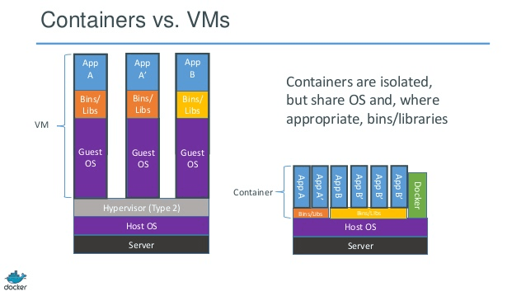

* Regular maintenance like OS patching is a lot easier on docker host than the VM host
* Performance of applications contained in containers is better than those hosted on VMs